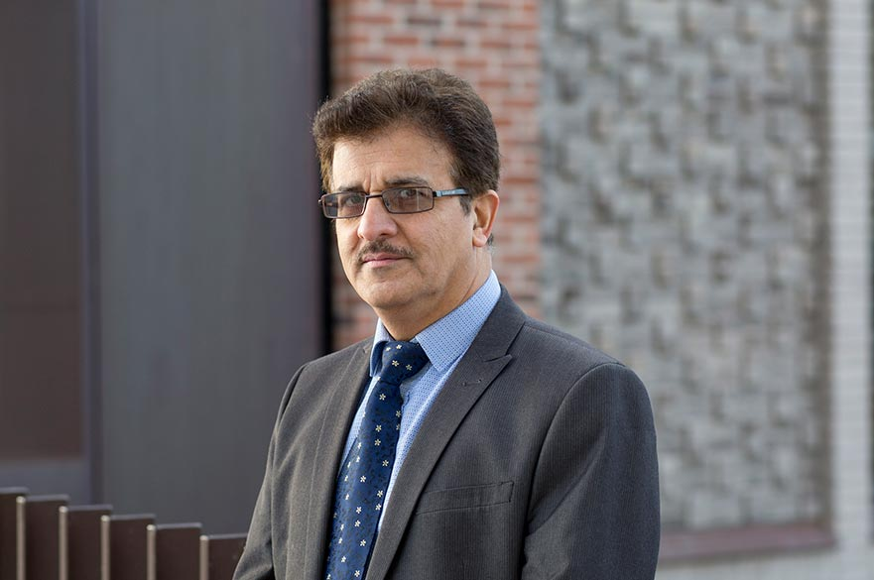 | Saeid Sanei  Professor  School of Science and Technology  Nottingham Trent University, UK

Title: Where AI meets Signal Processing

Professor Sanei is a professor of signal processing and machine learning. His research covers a wide area of signal processing and machine learning with major applications to computer networking, communications, speech and biomedical engineering, automation, brain computer interfacing (BCI), and big data. His contributions to tensor factorisation and cooperative networking are also the two main pillars of big data analytics. He has three books, a number of book chapters and over 350 peer reviewed papers mostly with IEEE.
His other areas of research includes:
- deep learning
- nature-inspired modelling
- compressive sensing
- convex and global optimisation
- modelling complex systems
- machine learning
- pattern recognition
- complex & quaternion – valued signals and systems, and the related applications to medical signals and images
- healthcare technology
- body sensor networking
- biometrics
- speech, and communication

External activity
He has been a Member of IEEE Machine Learning for Signal Processing Committee since 2013. He has often been invited as a Keynote speaker for prestigious international conferences, and to present in workshops in conferences, academia and industry.
Meeting, Workshop and Conference Organisation
- General Chair of the IEEE International Conference on Acoustics, Speech, and Signal Processing, ICASSP 2019, Brighton, UK.
- General Chair and Organiser of the 22nd International Conference on Digital Signal Processing, DSP 2017, London, UK
- Honorary Chair, 1st International Conference on Emerging Trends in Electrical, Electronic and Communication Engineering (ELECOM 2016), Mauritius
- Technical Co-Chair of European Signal Processing Conference, EUSIPCO 2016, Budapest, Hungary
- General Chair, IEEE International Workshop on Machine Learning for Signal Processing (MLSP 2013), UK
- Honorary Chair, Third international Conference on Bio-inspired Systems and Signal Processing, 2010, Valencia, Spain
- General Chair of IEEE Statistical Signal Processing Workshop, SSP 2009, Cardiff, UK
- Organising Chair of 17th International Conference on Digital Signal Processing, DSP 2007, Cardiff, UK.
Editorial Activities
- Associate Editor of Scientia Iranica Transactions on Electrical Engineering (since August 2017)
- Editorial Board Member of Journal of Signals (since March 2017)
- Editorial Board Member of Journal of Neurodevelopment Cognition (since November 2016)
- Guest Editor of the Journal of Bioengineering, Special Issue in Biomedical Signal Processing (since 2016)
- Guest Editor of the Sixth Special Issue on Advances in Biomedical Signal and Image Processing, and Biometrics, Elsevier Journal of Computers and Electrical Engineering (2015-2016)

Sponsors and collaborators
Professor Sanei collaborates with many national and international institutions, below are some examples:
- Department of Electrical & Electronic engineering, Imperial College London
- Department of Clinical Neuroscience, King’s College London
- Department of Computer Science, University of Surrey
- A-star and Department of Electrical & Electronic Engineering, National University of Singapore
- RIKEN Brain Institute, Japan
- Department of Electrical Engineering, UCLA, CA, USA

