**Call for Exhibitions**

The exhibition of the 10th International Conference on Signal Processing and Intelligent Systems will be held at the same time as this event. The purpose of the exhibition is to present the latest achievements in the areas of the conference, to reveal with the capabilities of domestic companies, and to create interaction and synergy between industrial partners.

**Exhibition place**

The exhibition will be held at the same place of the conference meetings in the Kharazmi Building in the Engineering and Modern Technologies Campus of Shahrood University of Technology (see the picture bellow)

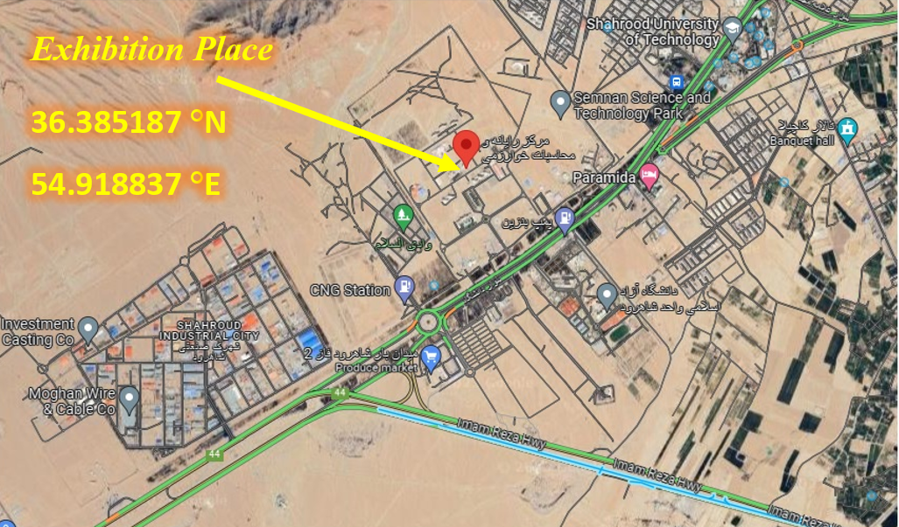

The present exhibition will be held in two similar halls, A and B. Each hall includes 12 booths, the minimum size of the booths is 2.5 square meters and the maximum is 18 square meters. If you need more space, it is possible to reserve two adjacent booths. The details of the dimensions and position of the booths are shown in the figure below.

**Information about booths**

The present exhibition includes 12 booths, the minimum size of the booths is 2.5 square meters and the maximum is 12 square meters (see the bellow figure for more details). If you need more space, it is possible to reserve two adjacent booths.

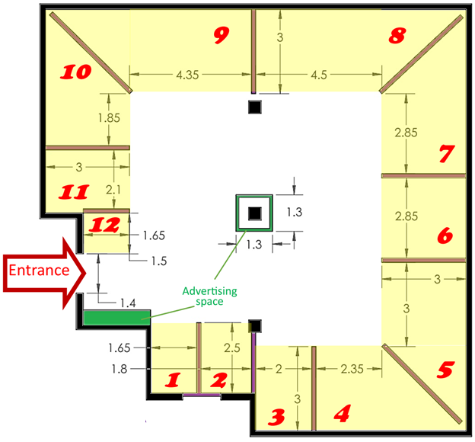

همچنین بسته های تلیغاتی در کنفرانس و نمایشگاه در نظر گرفته شده است که متقاضیان محترم می توانند در صورت تمایل بسته دلخواه را خریداری نماییند.

جهت هر گونه سوالات بیشتر و یا هماهنگی لازم، با دبیرخانه کنفرانس تماس گرفته شود.